

Department of Information Technology

Academic Year: 2019-20 Name of Student:Anuja Dhumale
Semester: VIII Student ID:16104034
Class / Branch: IT Date of Performance:20/1/2020
Subject: Big Data Analytics Date of Submission:20/1/2020
Name of Instructor: Prof. Vishal Badgujar

Experiment No. 2
Aim:Case study on Hadoop ecosystem.
1)What are the different ecosystem components of Hadoop with diagram.
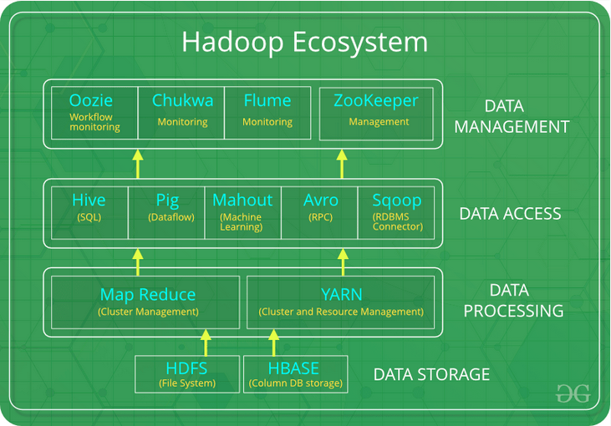
Ans:

2)Categorize Hadoop Ecosystem components based on its functionalities.
Ans:
a)HDFS:HDFS is the primary or major component of Hadoop ecosystem and is responsible for storing large data sets of structured or unstructured data across various nodes and thereby maintaining the metadata in the form of log files.
HDFS consists of two core components i.e.
  - Name node
  - Data Node
b)Yarn:YARN is the one who helps to manage the resources across the clusters. In short, it performs scheduling and resource allocation for the Hadoop System.
Consists of three major components i.e.
- Resource Manager
- Nodes Manager
- Application Manager


c)Mapreduce:MapReduce makes the use of two functions i.e. Map() and Reduce() whose task is:
- Map() performs sorting and filtering of data and thereby organizing them in the form of group. Map generates a key-value pair based result which is later on processed by the Reduce() method.
- Reduce(), as the name suggests does the summarization by aggregating the mapped data. In simple, Reduce() takes the output generated by Map() as input and combines those tuples into smaller set of tuples.
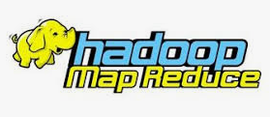

d)Pig:Pig was basically developed by Yahoo which works on a pig Latin language, which is Query based language similar to SQL.
- It is a platform for structuring the data flow, processing and analyzing huge data sets.
- Pig does the work of executing commands and in the background, all the activities of MapReduce are taken care of. After the processing, pig stores the result in HDFS.
- Pig Latin language is specially designed for this framework which runs on Pig Runtime. Just the way Java runs on the JVM.


e)Hive:With the help of SQL methodology and interface, HIVE performs reading and writing of large data sets. However, its query language is called as HQL (Hive Query Language).
- It is highly scalable as it allows real-time processing and batch processing both. Also, all the SQL datatypes are supported by Hive thus, making the query processing easier.
- Similar to the Query Processing frameworks, HIVE too comes with two components: JDBC Drivers and HIVE Command Line.


f)Mahout:Mahout, allows Machine Learnability to a system or application.Machine Learning, as the name suggests helps the system to develop itself based on some patterns, user/environmental interaction or om the basis of algorithms.


g)Apache Spark:It’s a platform that handles all the process consumptive tasks like batch processing, interactive or iterative real-time processing, graph conversions, and visualization, etc.


h)Apache HBase:It’s a NoSQL database which supports all kinds of data and thus capable of handling anything of Hadoop Database. It provides capabilities of Google’s BigTable, thus able to work on Big Data sets effectively.
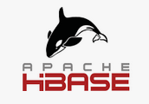
3)What are the use cases or real life examples for each ecosystem components
Ans:
4)What are the recent research areas based on these ecosystem components.
Ans:
Conclusion:In this experiment we have studied different components of hadoop ecosystem along with its functionalities use cases and research areas.

